# COMP3500: Process Control

**Difficulty Level:** 🟊: >85%, 🟊🟊: 70-85%, 🟊🟊🟊: 55-70%, 🟊🟊🟊🟊: 40-55%, 🟊🟊🟊🟊🟊: < 40%

🟊🟊🟊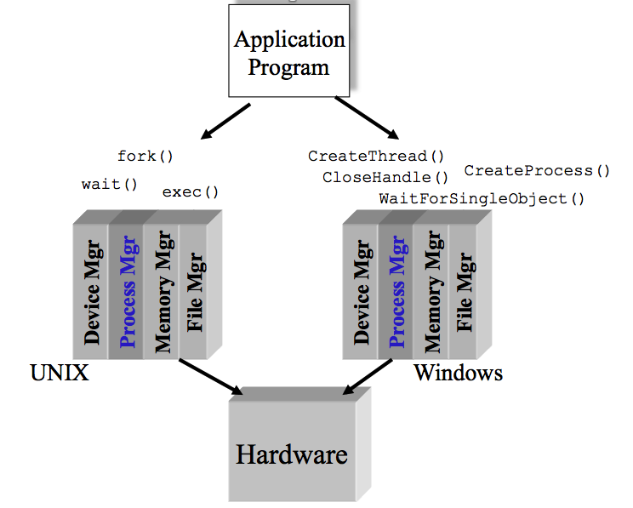 **Exercise 1 (Plickers):** Which one of the following is **not** a basic component in Microkernel? (30 seconds)

1. Process manager
2. Memory manager
3. IPC: inter-process communications
4. File manager

🟊🟊🟊🟊 **Exercise 2 (Plickers):** Which one of the following items is **not** a design goal of a process manager? Hint: You should focus on OS management of application execution. (30 seconds)

1. To improve CPU utilization
2. To switch a processor among multiple processes
3. To allocate memory resources to processes
4. To use processor more efficiently

**Exercise 3:** Which components does a ***running program*** have in a computer system? (1- minute group discussion)

**Exercise 4:** While the program is executing, what elements can uniquely characterize its process? (1- minute group discussion)

🟊🟊 **Exercise 5 (Plickers):** The context-switch time is OS overhead. The context-switch overhead depends on the following factors **except**. (1 Minute)

1. The complexity of the OS and PCB B. open source operating systems
2. Multiple sets of registers per CPU D. Multiple contexts loaded at once.

**Exercise 6:** What are the two possible process states? (30 seconds)

**Exercise 7:** What are the five process states? What’s a difference between “ready” and “waiting”? (30 seconds)

**Exercise 8:** What are maintained in the ready, blocked, and event queues? (20 seconds)

(30 seconds)

**Exercise 9:** Can you propose a new state Process model with the suspend state? (1 Minute)